Assignment 4: GIT(Hub) Viz

|  |  |  |  |  |
| --- | --- | --- | --- | --- |
| **Student Name** | Yap Han Chiang | Yang Jung Kai |  |  |
| **Matriculation Number** | A0125168E | A0121593J |  |  |

# Introduction

This assignment required us to choose 2 from the 5 sample visualizations introduced in assignment 4 and used them to better visualize of data for repo [https://github.com/tungnk1993/scrapy](https://github.com/tungnk1993/scrapy%20) found in assignment 3. Jung Kai has chosen to use pie chart to show the total number of commits made for the week from Monday to Sunday for the repo since it was created. Han Chiang has chosen to use a bar graph to show the weekly commit count of the contributors.

## 2. Visualizations - Purpose & Method

## 2.1 Pie Chart

Pie chart is used to show the total number of commits made from Monday and Sunday for the repo since it was created. Table 1 shows the result for total number of commits made for the week from Monday to Sunday and colors used to represent the day when creating the chart. Diagram 1 shows the chart created to represent the data in Table 1. We will be able to know the statistics for the commits made from Monday to Sunday since the creation of the repo just by looking at the pie chart. This information can be useful as it will let developers know which are the days that the contributors are more active and willing to contribute more to the repo so they can better plan the schedule for the contribution to the repo.

### 2.1.1 Step Taken To Create The Pie Chart

1. Firstly, use GITHub API to get all the commits for the week from Monday to Sunday since the creation of repo using the link <https://api.github.com/repos/tungnk1993/scrapy/stats/punch_card>.
2. Secondly, we use a java program to sum up the total number of commits from Monday to Sunday since the creation of repo.
3. Next, we input the data obtained into data.csv file and follow closely with the code example from <https://bl.ocks.org/mbostock/3887235> to create a html file which will display the pie chart for the total commits from Monday to Sunday since the creation of repo.
4. Lastly, we need to open command prompt in the folder containing chrome.exe and enter “chrome --allow-file-access-from-files” in order to display the pie chart on google chrome using the html file.

|  |  |  |
| --- | --- | --- |
|  |  |  |
| **Table 1: day, value and color** |  |  |

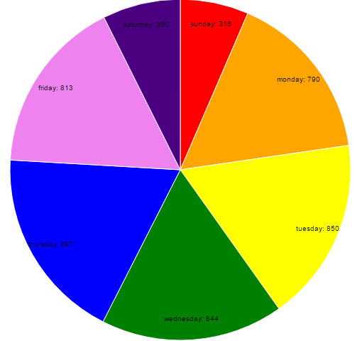 **Diagram 1: Pie chart for commits**

# **2.2 Bar graph**

The purpose of this bar graph is to show the weekly commit count of the contributors

* Use ajax to retrieve data from <https://api.github.com/repos/tungnk1993/scrapy/stats/participation>
* Parse the string data into an object
* Exclude results with 0 contributions
* Create a grid with 25 lines
* Set each tick in intervals of 10
* Create canvas, append svg
* Append grids to canvas
* Create a color scale
* Set x-axis to bottom and y-axis to left
* Shift the axes into position
* Append the data rectangles into the canvas

# 

